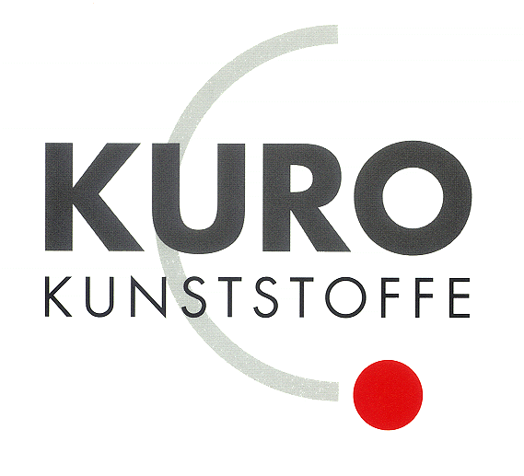

KURO – Information for invitation to tender

Product:
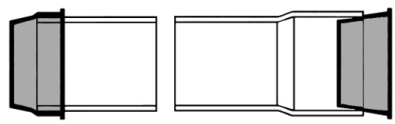

PP end cap

Information for invitation to tender:

 | Pos:....................... | PP end cap 50 mm / Colour: black
 |  | Material: PP dimensionally stable / suitable for socket and plain end
 |  | System KURO o. glw. (www.kuro-kunststoffe.de),
 |  | supply and install, as an addition to pos: ...........
 |  | Amount:............Pieces UP: ....... TP: ........

 | Pos:....................... | PP end cap 63 mm / Colour: black
 |  | Material: PP dimensionally stable / suitable for socket and plain end
 |  | System KURO o. glw. (www.kuro-kunststoffe.de),
 |  | supply and install, as an addition to pos: ...........
 |  | Amount:............Pieces UP: ....... TP: ........
 | Pos:....................... | PP end cap 75 mm / Colour: black
 |  | Material: PP dimensionally stable / suitable for socket and plain end
 |  | System KURO o. glw. (www.kuro-kunststoffe.de),
 |  | supply and install, as an addition to pos: ...........
 |  | Amount:............Pieces UP: ....... TP: ........
 | Pos:....................... | PP end cap 85 mm / Colour: black
 |  | Material: PP dimensionally stable / suitable for socket and plain end
 |  | System KURO o. glw. (www.kuro-kunststoffe.de),
 |  | supply and install, as an addition to pos: ...........
 |  | Amount:............Pieces UP: ....... TP: ........
 | Pos:....................... | PP end cap 90 mm / Colour: black
 |  | Material: PP dimensionally stable / suitable for socket and plain end
 |  | System KURO o. glw. (www.kuro-kunststoffe.de),
 |  | supply and install, as an addition to pos: ...........
 |  | Amount:............Pieces UP: ....... TP: ........
 |  | 
 | Pos:....................... | PP end cap 106 mm / Colour: black
 |  | Material: PP dimensionally stable / suitable for socket and plain end
 |  | System KURO o. glw. (www.kuro-kunststoffe.de),
 |  | supply and install, as an addition to pos: ...........
 |  | Amount:............Pieces UP: ....... TP: ........
 | Pos:....................... | PP end cap 125 mm / Colour: black
 |  | Material: PP dimensionally stable / suitable for socket and plain end
 |  | System KURO o. glw. (www.kuro-kunststoffe.de),
 |  | supply and install, as an addition to pos: ...........
 |  | Amount:............Pieces UP: ....... TP: ........
 | Pos:....................... | PP end cap 126 mm / Colour: black
 |  | Material: PP dimensionally stable / suitable for socket and plain end
 |  | System KURO o. glw. (www.kuro-kunststoffe.de),
 |  | supply and install, as an addition to pos: ...........
 |  | Amount:............Pieces UP: ....... TP: ........
 | Pos:....................... | PP end cap 140 mm / Colour: black
 |  | Material: PP dimensionally stable / suitable for socket and plain end
 |  | System KURO o. glw. (www.kuro-kunststoffe.de),
 |  | supply and install, as an addition to pos: ...........
 |  | Amount:............Pieces UP: ....... TP: ........
 | Pos:....................... | PP end cap 158 mm / Colour: black
 |  | Material: PP dimensionally stable / suitable for socket and plain end
 |  | System KURO o. glw. (www.kuro-kunststoffe.de),
 |  | supply and install, as an addition to pos: ...........
 |  | Amount:............Pieces UP: ....... TP: ........
 | Pos:....................... | PP end cap 160 mm / Colour: black
 |  | Material: PP dimensionally stable / suitable for socket and plain end
 |  | System KURO o. glw. (www.kuro-kunststoffe.de),
 |  | supply and install, as an addition to pos: ...........
 |  | Amount:............Pieces UP: ....... TP: ........

